Literacy support worksheet

4.1 Resources on Earth are either renewable or non-renewable

Pages 62–63

Renewable and non-renewable resources

1 Look at each picture below and write whether it is a continuous, renewable or non-renewable resource.

|  |  |  |
| --- | --- | --- |
| Resource image | Type of resource | Overview of the resource |
| WS0409A_00883-r |  | Ocean waves can be used to generate electricity |
| WS0410_00883-r |  | Plants are regrown by the seeds they produce |
| WS0411_00883-r |  | Wind is used to turn turbines to generate electricity |
| WS0412_00883-r |  | Electricity is generated from the burning of coal |
| WS0413_00883-r |  | Forests can be replanted after logging occurs |
| WS0414_00883-r |  | Oil is extracted and is one of the world’s most commonly used energy sources |

2 Renewable or non-renewable? Circle the correct answer for each of the resources below using your knowledge of environmental resources.

a Petrol for your family car: Renewable Non-renewable

b The wind that turns a turbine: Renewable Non-renewable

c The coal that provides electricity: Renewable Non-renewable

d The water you drank yesterday: Renewable Non-renewable

e A plastic wrap you had your lunch in: Renewable Non-renewable

3 Energy from the Sun is a renewable resource called solar power. In the box below, write and draw diagrams of inventions that use solar power.

|  |
| --- |
|  |

WORD DETECTIVE

4 Match-a-word

Draw a line from the words to their meanings.

Minerals A renewable resource that is under threat

Waves The world’s most commonly used energy source

Oil Used by holidaymakers and to generate electricity

Forests Provides solar power

Sun Mined from the ground; uranium is an example

Literacy support worksheet

4.2 Renewable resources can be quickly replaced

Pages 64–65 and 186

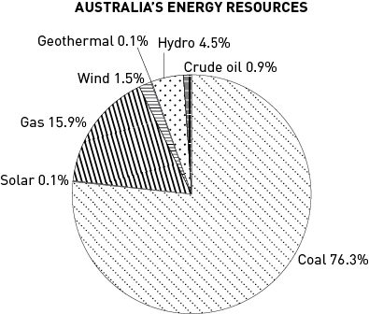Replaceable resources

1 The pie chart shows the use of Australia’s energy resources.

a Rank the energy resources from highest percentage use to the lowest.

b List the energy resources that are from renewable energy sources.

c How much energy comes from renewable resources?

d Look at the pie chart showing Australia’s mining exports. How do you think the exports might affect the environment when used overseas?

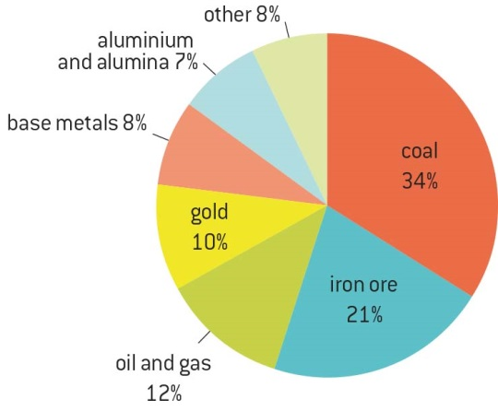

**AUSTRALIA’S MINING EXPORTS, 2009**

2 Use the pictures at the bottom of the map of Australia (Legend) in the textbook, to answer the following questions.

a Where are most of the wind power stations found?

b Why do you think the wind power stations are found next to the sea (the coast) in Australia?

c Where in Australia are most of the coal energy resources found?

WORD DETECTIVE

3 Word search

Find the words listed, in the puzzle below.

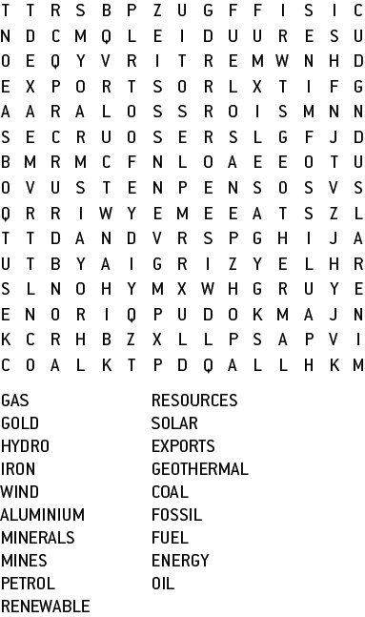

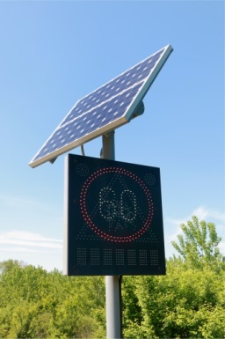Literacy support worksheet

4.3 Renewable resources can be harnessed to provide energy

Pages 66–67 and 188

Renewable energy

1 Fill in the renewable energy source from below that matches with the correct advantages and disadvantages listed in the table.

solar energy geothermal energy wind energy

tidal energy hydroelectric energy

|  |  |  |
| --- | --- | --- |
| Renewable resource | Advantages (global) | Disadvantages (local) |
|  | No pollution (emissions)  Little environmental impact | Wind needs to be blowing  Visually not desired |
|  | No pollution (emissions)  Natural source of energy | Relies on the Sun being present  Expensive to make and organise (infrastructure) |
|  | Constant energy source  Cheap source of energy | Expensive to make and organise (infrastructure)  Long-term impact on the Earth not yet known |
|  | Renewable energy source  Stores water for other uses | Requires large dams and flooding of valleys |
|  | Offshore, so there is little visual impact  Constant source of energy | Expensive to make and organise (infrastructure)  Impact on the local ecosystem |

2 Provide real-life examples of how you have experienced a renewable energy resource. For example, ‘I have visited the hot springs in New Zealand’ could be your experience of geothermal energy.

a The power of the wind:

b The power of the Sun:

c The power of the waves or tides:

d The power of flowing water:

e The power of the Earth’s heat:

WORD DETECTIVE

3 Fill in the blanks

Fill in the blanks using the following words:

windmill barrage generate electricity panels surface turbines energy water

Wind energy is moving air. The wind turns large \_ \_ \_ \_ \_ \_ \_ \_- like blades to produce \_ \_ \_ \_ \_ \_ \_ \_ \_ \_ \_. Solar \_ \_ \_ \_ \_ \_ turn the Sun’s light into electricity. Hydro energy involves \_ \_ \_ \_ \_ flowing from a dam over \_ \_ \_ \_ \_ \_ \_ \_. Geothermal \_ \_ \_ \_ \_ \_ uses heat stored below the Earth’s \_ \_ \_ \_ \_ \_ \_ to generate power. Tidal energy involves a dam or \_ \_ \_ \_ \_ \_ \_ being built and water is pushed through turbines to \_ \_ \_ \_ \_ \_ \_ \_ electricity.

Literacy support worksheet

4.4 Non-renewable resources are limited

Pages 68–69 and 189–190

Fossil fuels

1 Review your understanding of the formation of coal by describing what happens at each stage:

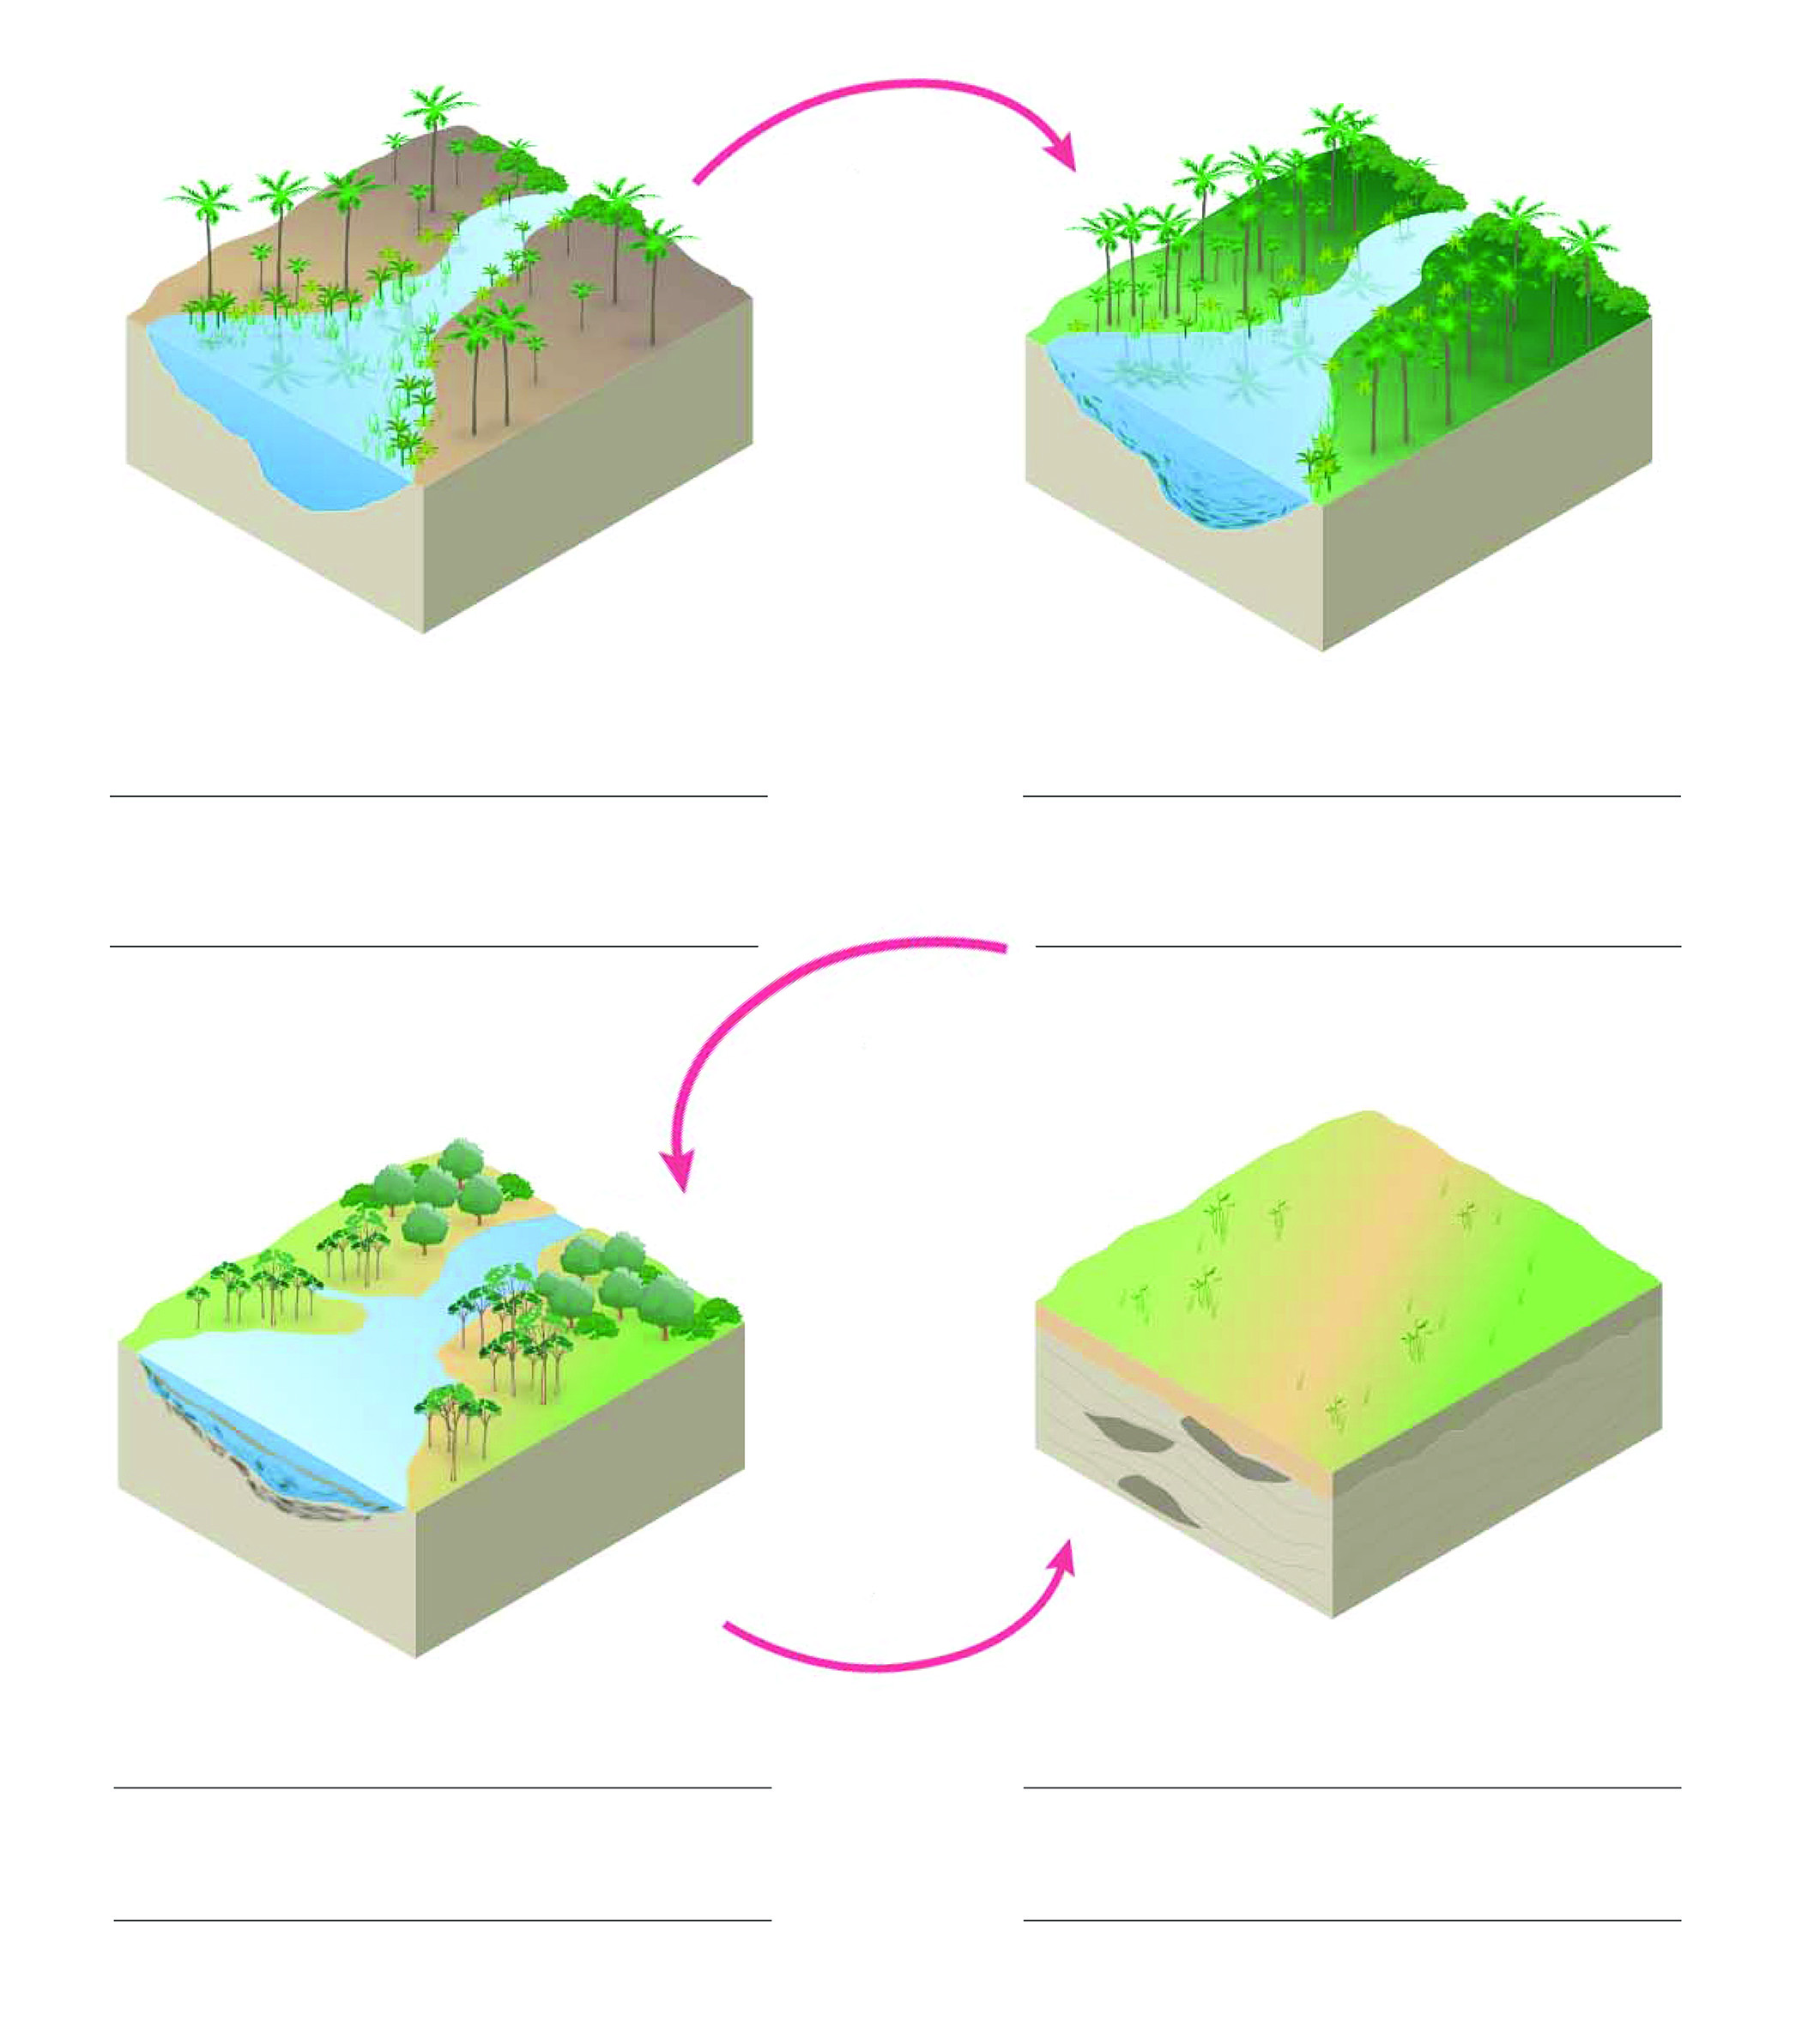

2 Using the ‘formation of coal’ diagram as a guide, draw a simple flow-chart to explain how oil and gas were formed.

**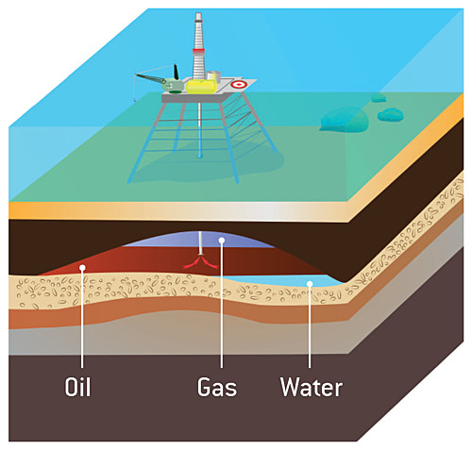**3 Why is the formation of coal, oil and gas so similar?

WORD DETECTIVE

4 Secret message

Use words from the student book to work out the secret message below:

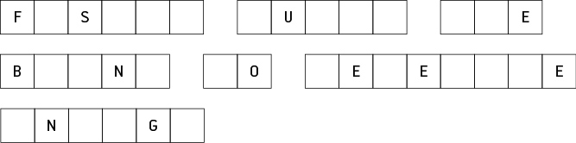

Literacy support worksheet

4.5 Soil is one of our most valuable resources

Pages 70–71 and 191

Soil as a resource

1 What ingredients make good soil?

2 The diagram below is a soil profile and shows the different layers in the soil.

a Use the following words to label the different layers of the soil profile:

Small and larger rocks Grass and leaf litter Hard rock layer Humus

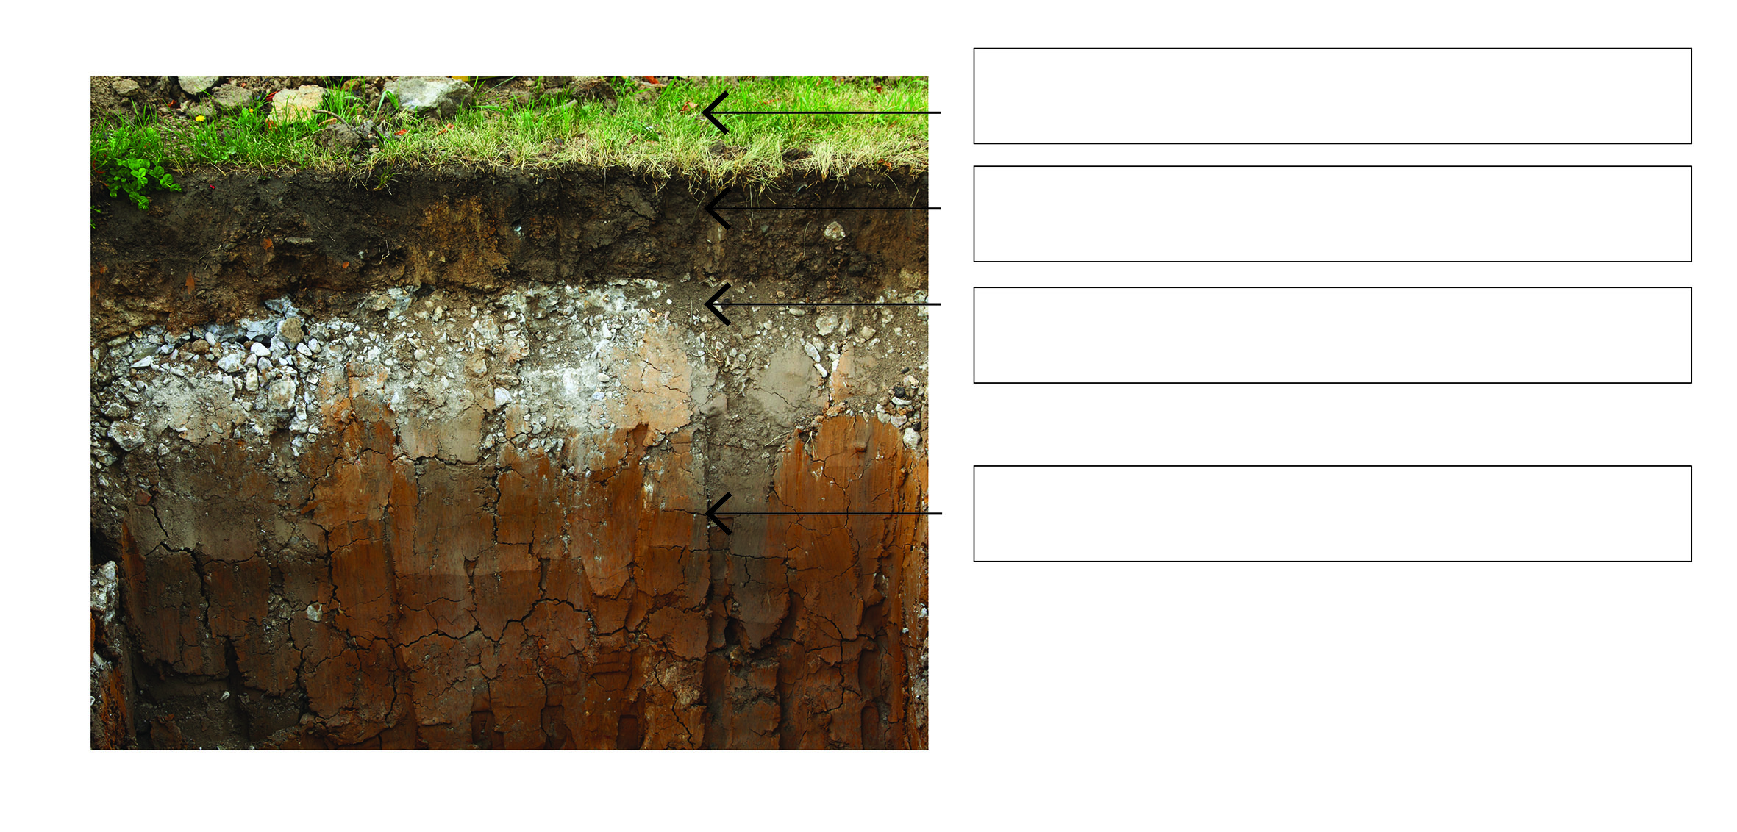

b Which layer of the soil would you find decomposed plants and animals in?

WORD DETECTIVE

3 Crossword

Read the clues below and complete the crossword.

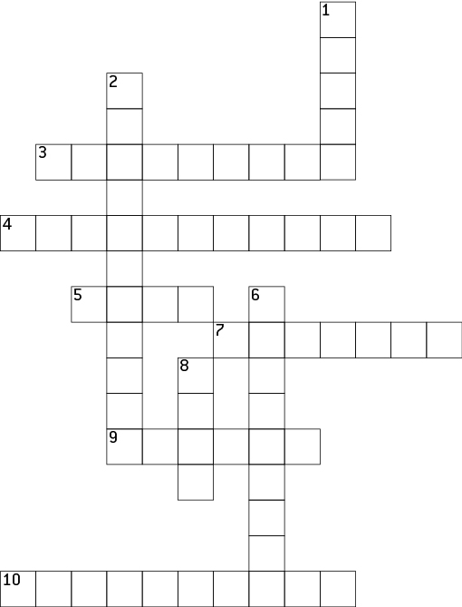

|  |  |
| --- | --- |
| **Across** | **Down** |
| 3 Soil provides essential \_\_\_\_\_\_\_\_\_\_\_\_ for all plants  4 Land care groups help manage land \_\_\_\_\_\_\_\_\_\_\_\_  5 A valuable resource needed for plants to grow  7 Land clearing and grazing have caused \_\_\_\_\_\_\_\_\_\_\_\_  9 The ability of water to pass through the soil  10 Man-made additive used to improve soil | 1 Decomposed animals and plants  2 Too much water in soil for plants to grow  6 Living and dead things found in soil  8 What happens to clay soil when water can’t drain easily |

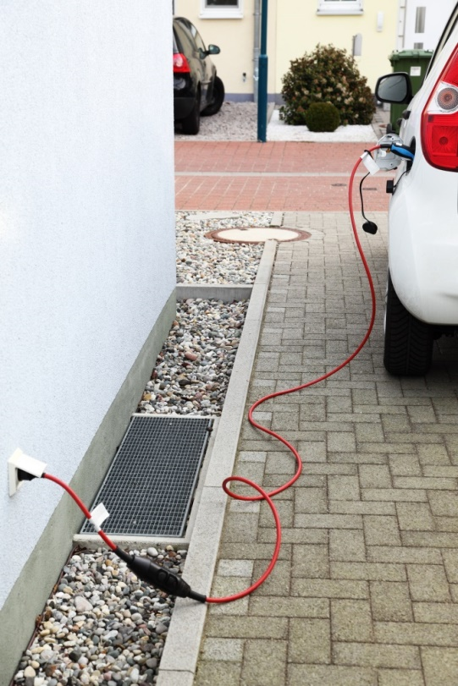Literacy support worksheet

4.6 Our future depends on careful management of resources

Pages 72–73 and 192

Resource management

1 Complete the following sentences.

a LEVs are:

b Hybrids use a mix of:

c Ethanol is a type of:

2 What could the ‘smart home’ of the future do to manage resources in these situations?

a You left your bedroom light on when you left for school.

b You also left the television on.

c You flush the toilet.

WORD DETECTIVE

3 Mumbo-jumbo

a Use the marked letters to find the secret word (e.g. olusntoi = solution).

b Unscramble each of the clue words below to find the message.

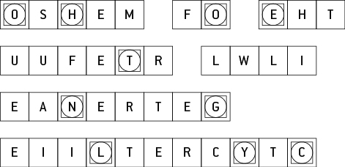

Secret word: \_\_\_\_\_\_\_\_\_\_\_\_\_\_\_\_\_\_\_\_\_\_\_\_\_\_\_\_\_\_\_\_\_\_\_\_\_\_\_\_\_\_\_\_\_\_\_\_\_\_\_\_\_\_\_\_\_\_\_\_\_\_\_\_\_\_\_\_\_\_\_\_\_\_

Message: \_\_\_\_\_\_\_\_\_\_\_\_\_\_\_\_\_\_\_\_\_\_\_\_\_\_\_\_\_\_\_\_\_\_\_\_\_\_\_\_\_\_\_\_\_\_\_\_\_\_\_\_\_\_\_\_\_\_\_\_\_\_\_\_\_\_\_\_\_\_\_\_\_\_\_\_

Literacy support worksheet

4.7 Green jobs will increase in the future

Pages 74–75

Green jobs

The images below show different people working in green jobs.

Choose one of the green jobs – think about what that person’s job might be and imagine that you are that person, then complete the sentences.

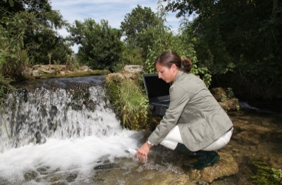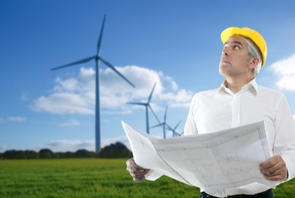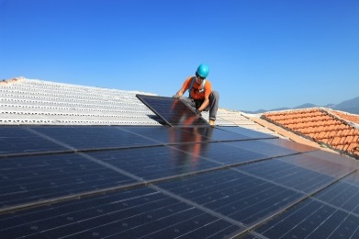

1 My job: \_\_\_\_\_\_\_\_\_\_\_\_\_\_\_\_\_\_\_\_\_\_\_\_\_\_\_\_\_\_\_\_\_\_\_\_\_\_\_\_\_\_\_\_\_\_\_\_\_\_\_\_\_\_\_\_\_\_\_\_\_\_\_\_\_\_\_\_\_\_\_\_\_\_

2 The ways my job helps the environment in the future is: \_\_\_\_\_\_\_\_\_\_\_\_\_\_\_\_\_\_\_\_\_\_\_\_\_\_\_\_\_\_\_\_\_\_\_\_\_

WORD DETECTIVE

3 Word search

Find as many words related to green jobs as possible in the puzzle below.

